CTM-I Use Case

Control Update

Version 0.1

Use Case Name | Control Update
Actor | Market Operations, Operations, App Support
Pre-conditions /Assumptions | User has Browser and is aware of the http path to the application.  User has successfully logged into the CTM-I application.  User has the right role to see the menu options.
Post Conditions | None
Screenshot | 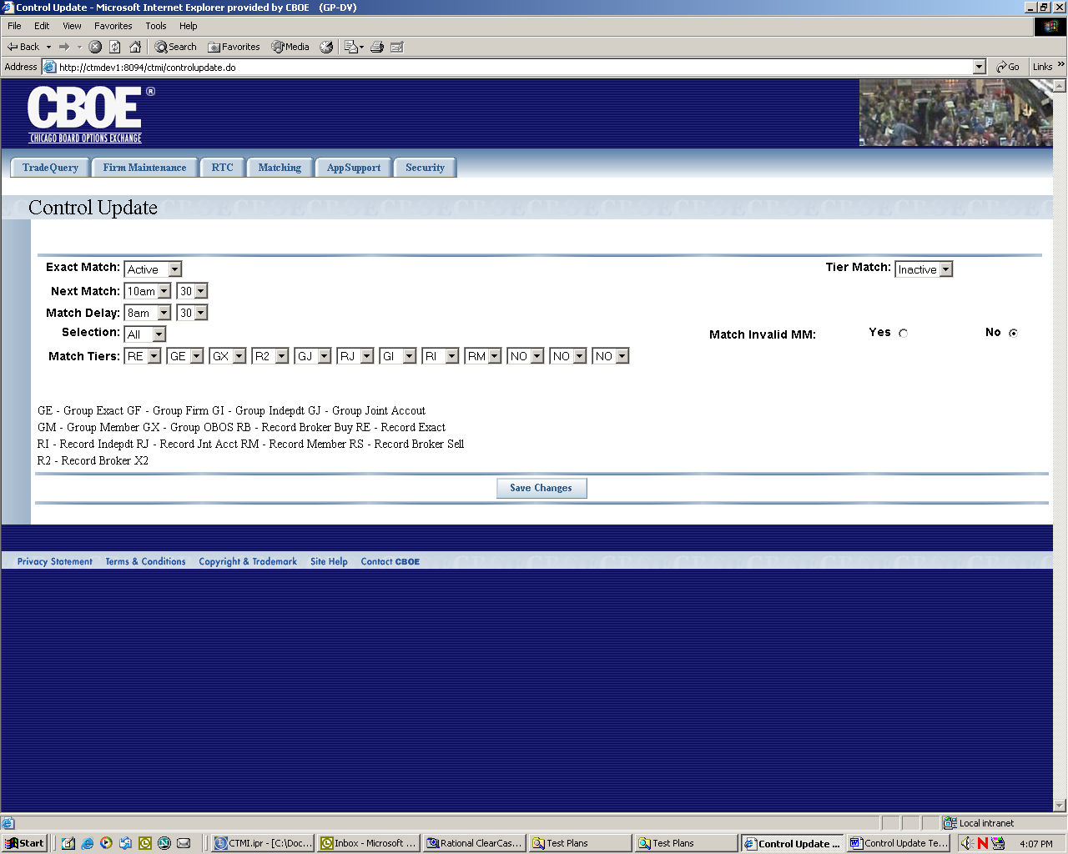
Flow of Events | - User selects “Control Update” from the menu.  - A request is sent to CTM-R to get the current values for matching  - The Control Update screen is displayed.  - The following editable fields are displayed  - Exact Match – Selection of “Active” and “Inactive”  - Tier Match – Selection of “Active” and “Inactive”\  - Next Match  - Match Delay  - Selection – Selection of “All” and “As Of”  - Match Invalid Market Maker – Choice of “Yes” or “No”  - Match Tiers – 12 selection fields that allow a user to select a matching process for each tier. They possible values are GE, GF, GI, GJ, GM, GX, RB, RE, RI, RJ, RM, RS and R2.  - The user presses the button “Save Changes” to save the changes.  - The changes are sent to CTM-R to process.  - The results of the CTM-R processing are displayed on the screen
Alternative Path | None

